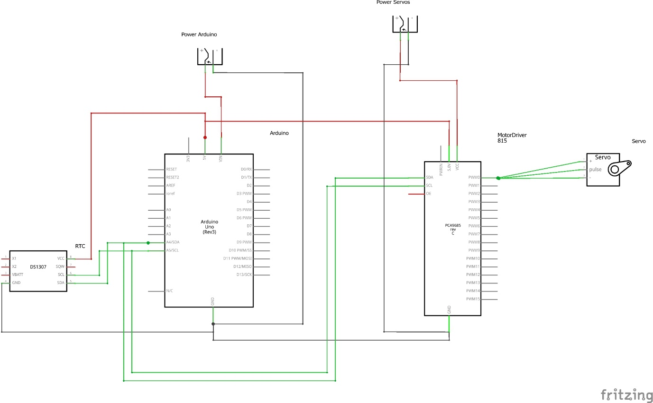

Parts required:

1x DS1307 (RTC module)

1x Arduino Uno

2x Power source

1x PCA9685 PWM Controller

16x Servos